BÁO CÁO THỰC HÀNH LAB 4  
LẬP TRÌNH HƯỚNG ĐỐI TƯỢNG

# Inheritance and Polymorphism

## 3. Creating the Book class

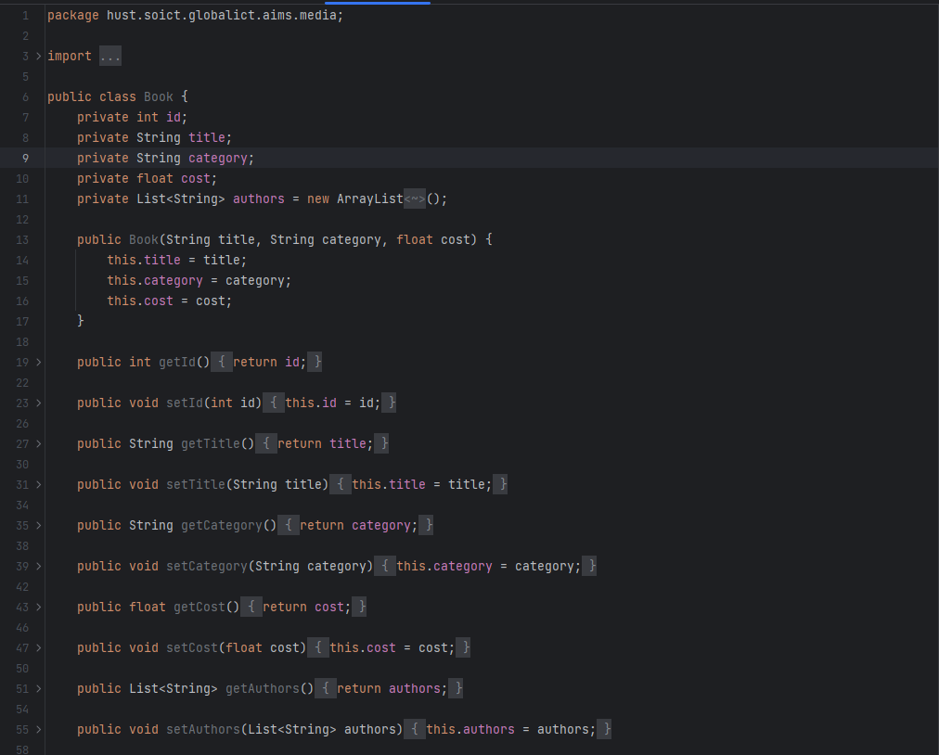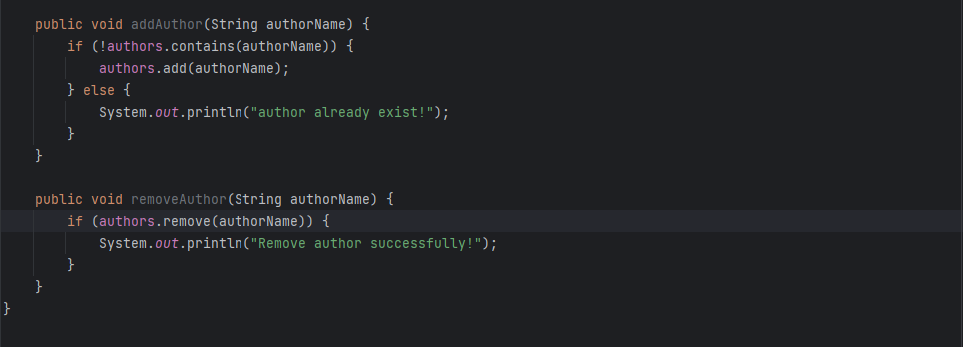

## 4. Creating the abstract Media class

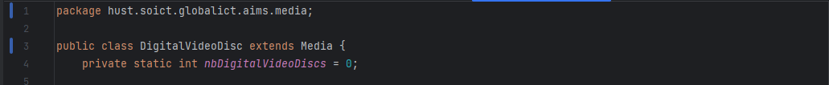

## 5. Creating the CompactDisc class

#### 5.1. Create the Disc class extending the Media class

#### 5.2. Create the Track class which models a track on a compact disc and will store information incuding the title and length of the track

#### 5.3. Open the CompactDisc class

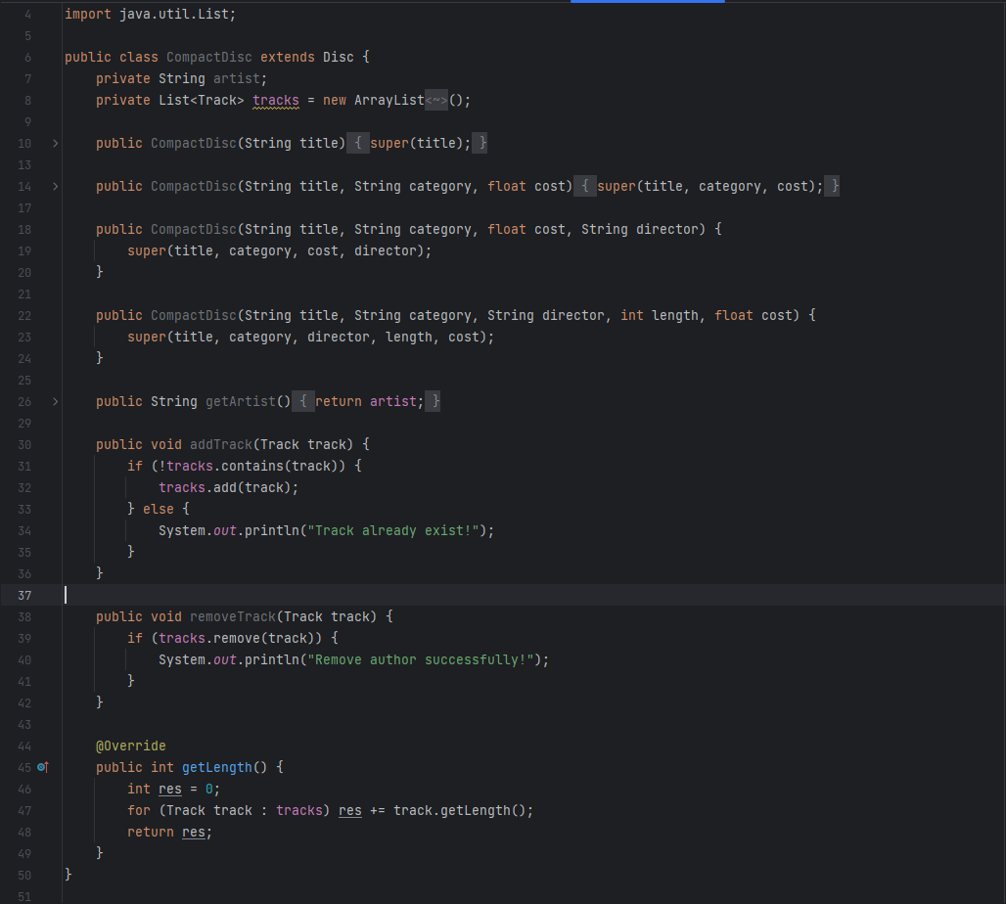

## 6. Create the Playable interface

## 7. Update the Cart class to work with Media

## 8. Update the Store class to work with Media

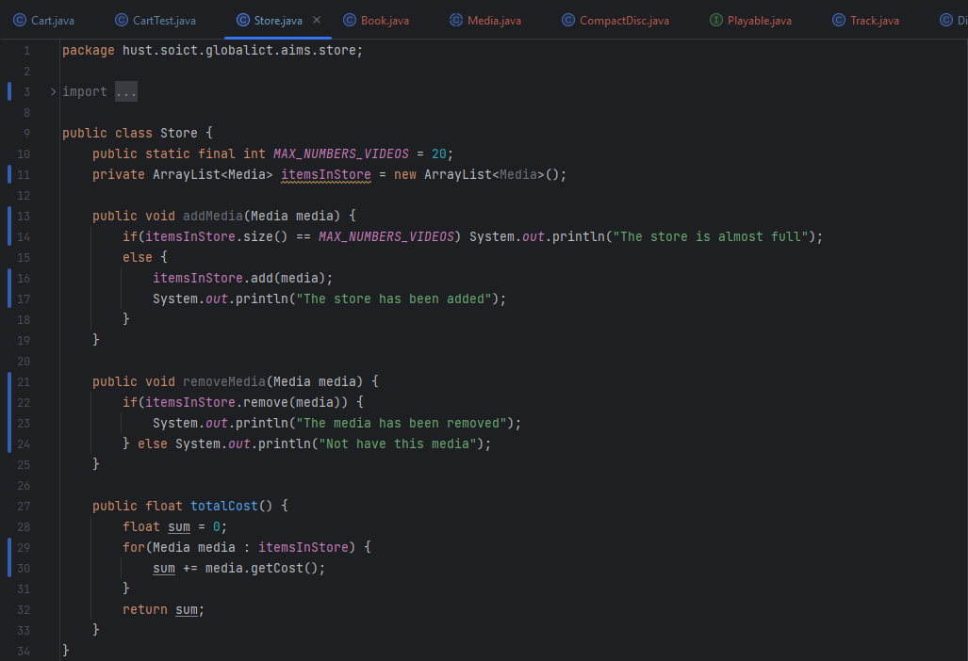

## 10. Unique item in a list

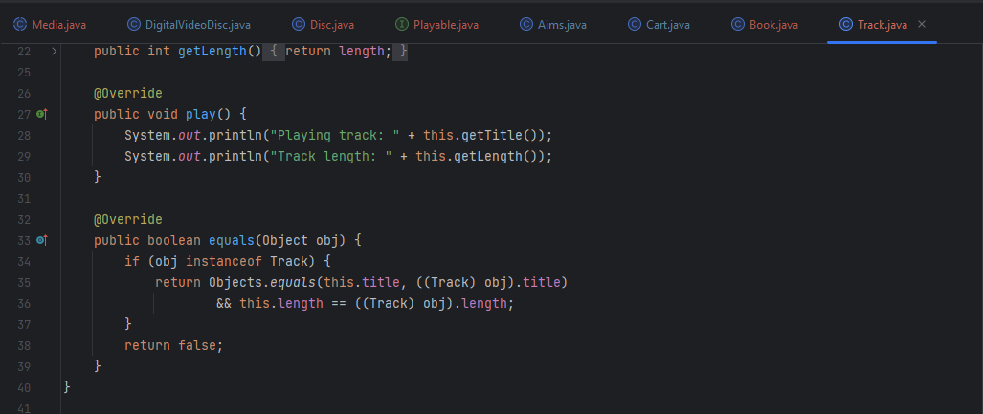

## 12. Sort media in the cart

